CPE301 – SPRING 2019

Midterm 1

Student Name: Brian West

Student #: 5003032874

Student Email: [westb2@unlv.nevada.edu](mailto:westb2@unlv.nevada.edu)

Primary Github address: https://github.com/westbrian2/Spring2019

Directory: Spring2019/Midterms/Midterm1

Submit the following for all Labs:

1. In the document, for each task submit the modified or included code (only) with highlights and justifications of the modifications. Also, include the comments.
2. Use the previously create a Github repository with a random name (no CPE/301, Lastname, Firstname). Place all labs under the root folder ESD301/DA, sub-folder named LABXX, with one document and one video link file for each lab, place modified asm/c files named as LabXX-TYY.asm/c.
3. If multiple asm/c files or other libraries are used, create a folder LabXX-TYY and place these files inside the folder.
4. The folder should have a) Word document (see template), b) source code file(s) and other include files, c) text file with youtube video links (see template).

1. **COMPONENTS LIST AND CONNECTION BLOCK DIAGRAM w/ PINS**

COMPONENTS: Xplained Mini board, LM35, ESP8266, ESP01 to USB module

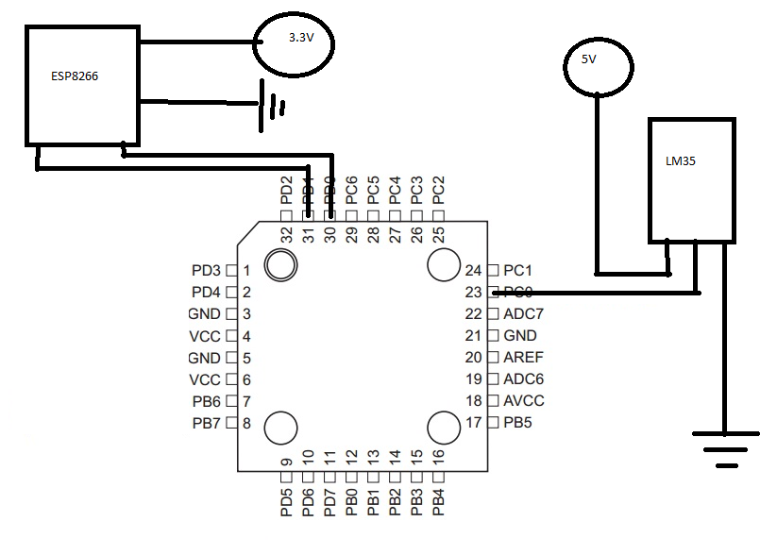

1. **INITIAL/MODIFIED/DEVELOPED CODE OF TASK 1/A**

#define *F_CPU* 16000000UL

#define UBRR_9600 103 //Baud rate for 16MHz

#include <avr/io.h>

#include <util/delay.h>

#include <stdio.h>

void read_adc(void);

void adc_init(void);

void USART_init( unsigned int ubrr ); //Sets up usart for use

void USART_tx_string( char *data ); //function that outputs data (usart)

char output[50]; //used to output value

volatile unsigned int adc_temp; //holds temp value

int main(void){

adc_init(); //setting up ADC

USART_init(UBRR_9600);

USART_tx_string("test\r\n");//testing usart

*snprintf*(output,sizeof(output),"AT+CWJAP=\"SSID\",\"password\"\r\n"); //connects to network

USART_tx_string(output);

*_delay_ms*(150);

while(1){

read_adc();

*snprintf*(output,sizeof(output),"AT+CIPSTART=\"TCP\",\"api.thingspeak.com\",80\r\n"); //starts session

USART_tx_string(output);//connecting to thingspeak

*_delay_ms*(300);

*snprintf*(output,sizeof(output),"AT+CIPSEND=51\r\n"); //prepares to send data

USART_tx_string(output);//

*_delay_ms*(300);

*snprintf*(output,sizeof(output),"GET /update?key=1ZGZ1P4HHEO19YA2&field1=%3d \\r\\n\r\n",adc_temp);

USART_tx_string(output);//send temp value

*_delay_ms*(300);

*snprintf*(output,sizeof(output),"AT+CIPCLOSE\r\n");

USART_tx_string(output); //close session

*_delay_ms*(1000);

}

}

void USART_init(unsigned int ubrr){

UBRR0H=(unsigned char)(ubrr>>8); //Setting up

UBRR0L=(unsigned char)(ubrr);

UCSR0B=(1<<TXEN0)|(1<<RXEN0);//Enabling reciever, transmitter, and rx interrupt

UCSR0C=(1<<UCSZ01)|(1<<UCSZ00); //async 8 n 1

}

void USART_tx_string(char *data){ //sends string

while((*data!= '\0')){

while(!(UCSR0A&(1<<UDRE0)));

UDR0=*data;

data++; //gets next part of data

}

}

void adc_init(void)

{

/** Setup and enable ADC **/

ADMUX = (0<<REFS1)| // Reference Selection Bits

(1<<REFS0)| // AVcc - external cap at AREF

(0<<ADLAR)| // ADC Left Adjust Result

(0<<MUX2)| // setting input to PC0

(0<<MUX1)|

(0<<MUX0);

ADCSRA = (1<<ADEN)| // ADC enable

(0<<ADSC)| // ADC Start Conversion

(0<<ADATE)| // ADC Auto Trigger Enable

(0<<ADIF)| // ADC Interrupt Flag

(0<<ADIE)| // ADC Interrupt Enable

(1<<ADPS2)| // ADC Prescaler Select Bits

(0<<ADPS1)|

(1<<ADPS0); // Select Channel

}

void read_adc(void) {

unsigned char i =4; //to get 4 samples

adc_temp = 0;

while (i--) {

ADCSRA |= (1<<ADSC); //start conversion

while(ADCSRA & (1<<ADSC)); //waiting for coversion to finish

adc_temp+= ADC;

*_delay_ms*(50);

}

adc_temp = (adc_temp / 4)-20; // Average a few samples and adjusts for slight offset

}

1. **SCHEMATICS**

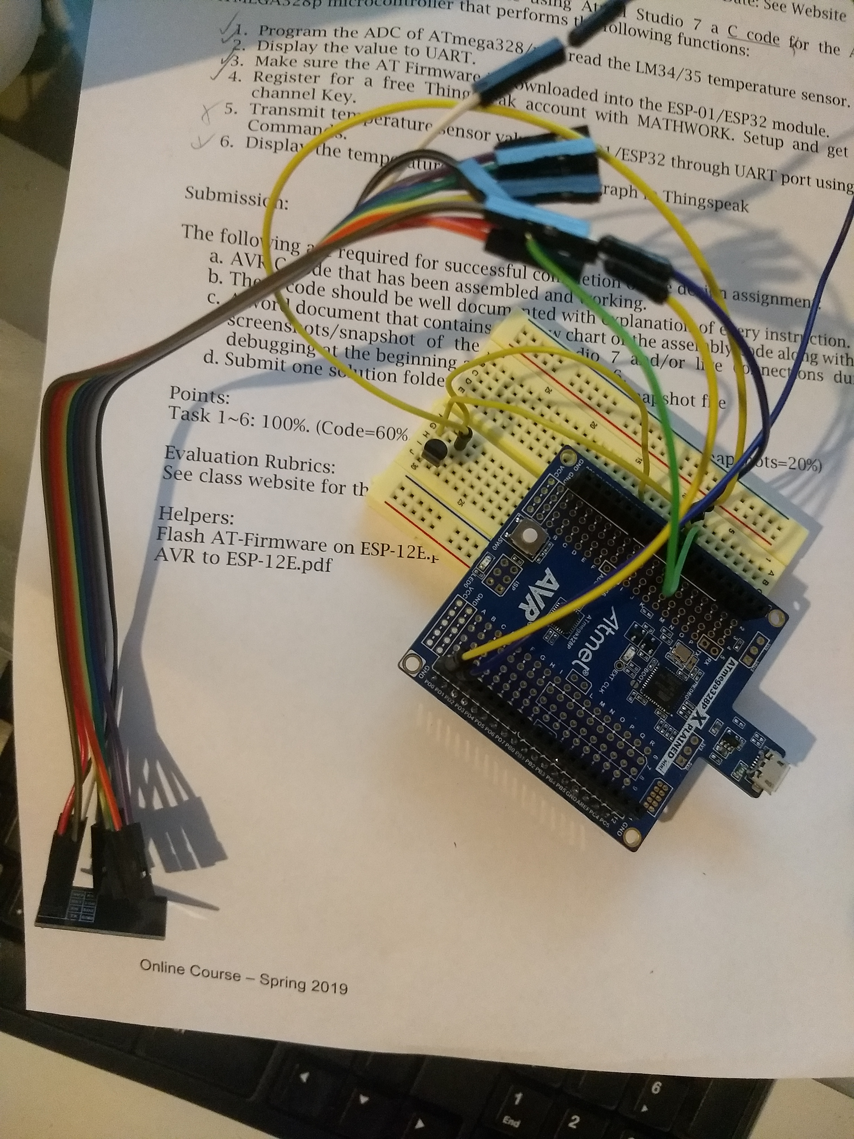

Picture of the board wired

1. **SCREENSHOTS OF EACH TASK OUTPUT (ATMEL STUDIO OUTPUT)**

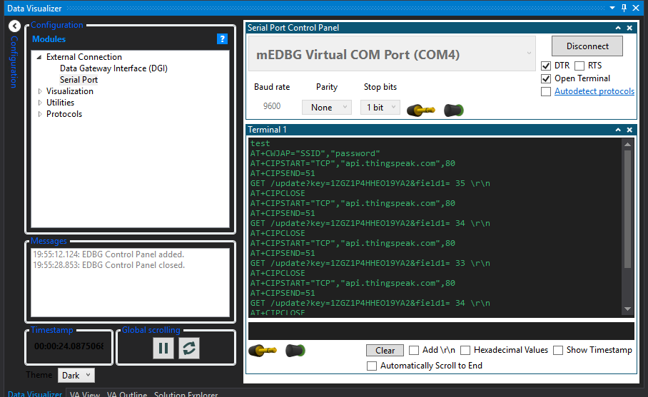

Screenshot of UART output working.

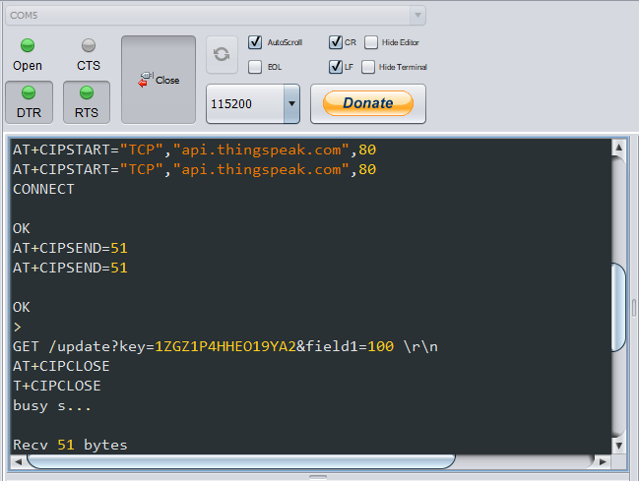

Picture showing the ESP8266 was programmed correctly when programmed from computer

I fixed the issue I was having with the flasher program by changing to an older version of JDK.

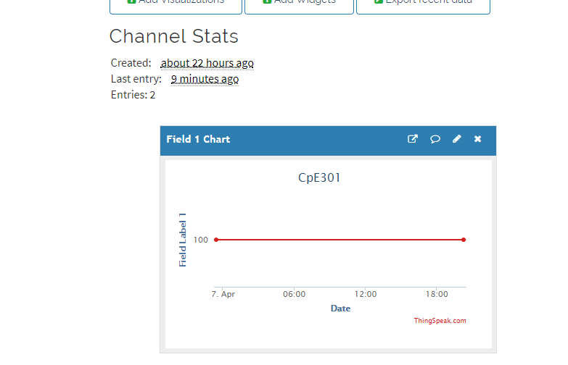

Picture showing that I was able to get the ESP to send data to thingspeak using ESPlorer.

1. **VIDEO LINKS OF EACH DEMO**

I really don’t know what you would want videos of.

1. **GITHUB LINK OF THIS DA**

https://github.com/westbrian2/Spring2019/Midterms/Midterm1

**Student Academic Misconduct Policy**

<http://studentconduct.unlv.edu/misconduct/policy.html>

“This assignment submission is my own, original work”.

Brian West